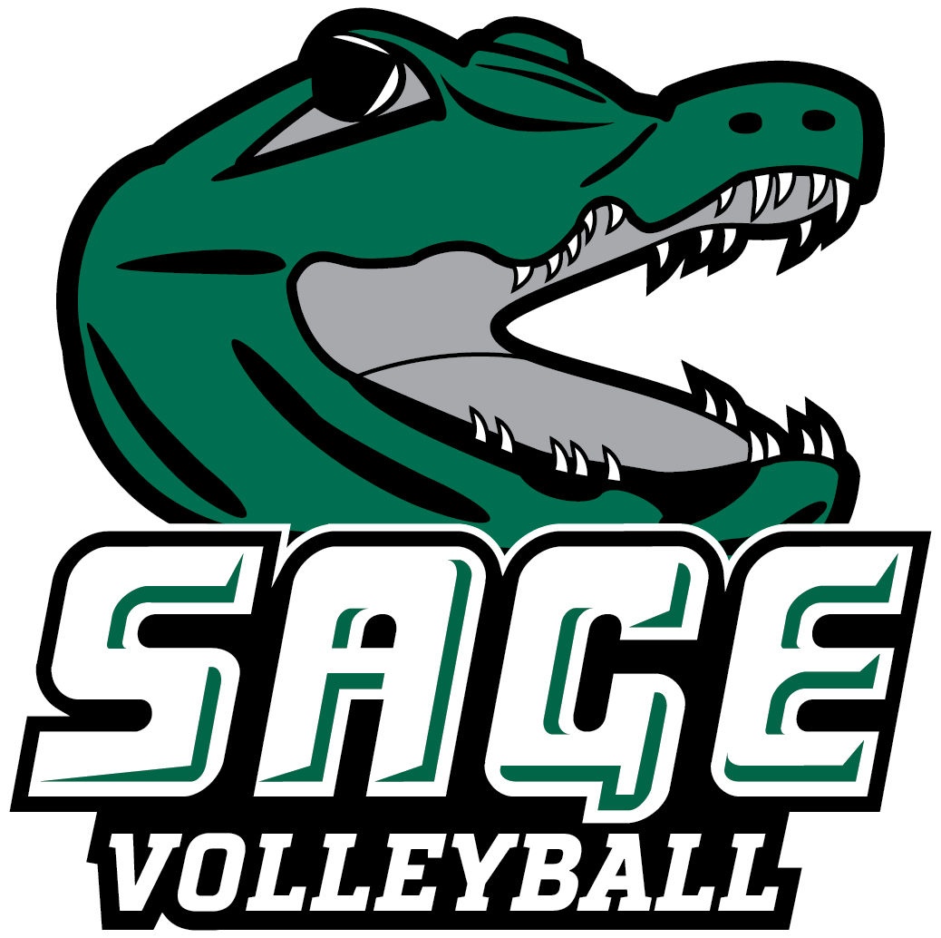
2023 RUSSELL SAGE COLLEGE WOMEN’ S VOLLEYBALL
“THE GATORS”

NO. NAME CL. POS. HT. HOMETOWN/HIGH SCHOOL
1 Katherine Jepsen** Jr. OH 5-6 Hudson, NY/Hudson
3 Elaina Moisidis* *** Gr. L 5-0 Albany, NY/Albany
4 Kailey Brooks Fr. DS 4-11 Exeter, RI/Exeter-West Greenwich
5 Macey Salvione Jr. OH 5-3 Johnstown, NY/Gloversville
7 Monalissa Carius*** Sr. MH 5-7 Hudson, NY/Hudson
8 Savannah Petersen* Jr. OH 5-5 Schenectady, NY/Schenectady
9 Aniyah Kelley* So. MH 5-10 Newcastle, DE/William Penn
11 Ashleigh Gerkman* So. OH 5-5 Valatie, NY/Ichabod Crane
12 Allison Louque* So. MH 6-1 Westminster, MD/Winters Mill
13 Caitlin Hammecker* Sr. RS 5-10 Warnerville, NY/Cobleskill-Richmondville
14 Emma Friedel So. S 5-7 Utica, NY/New Hartford
16 Madeline Mott Fr. OH 5-4 Fultonville, NY/Fonda-Fultonville
23 Shea Bryant* So. RS 5-8 Cohoes, NY/Cohoes
32 Mia Wood* So. S 5-6 Scotia, NY/Scotia-Glenville
Head Coach: Rosilyn Cummings (First Season, SUNY Plattsburgh ’13)
Assistant Coach: Reid Hartl
* Indicates Letters Won + Indicates Leadership Council

Pronunciation Guide
3 Elaina Moisidis Ee-Lane-A Mo-Seed-eez 5 Macey Salvione Sal-Vee-Own
7 Monalissa Carius Mona-lisa Carry-us 9 Aniyah Kelley Ann-ny-yah
11 Ashleigh Gerkman Ash-leigh Gerk-man 12 Allison Louque Luke
13 Caitlin Hammecker Ham-meck-er 14 Emma Friedel Free-dell

October 20, 2023

Office of Athletic Communications 140 New Scotland Avenue • Albany, NY 12208
www.sagegators.com

