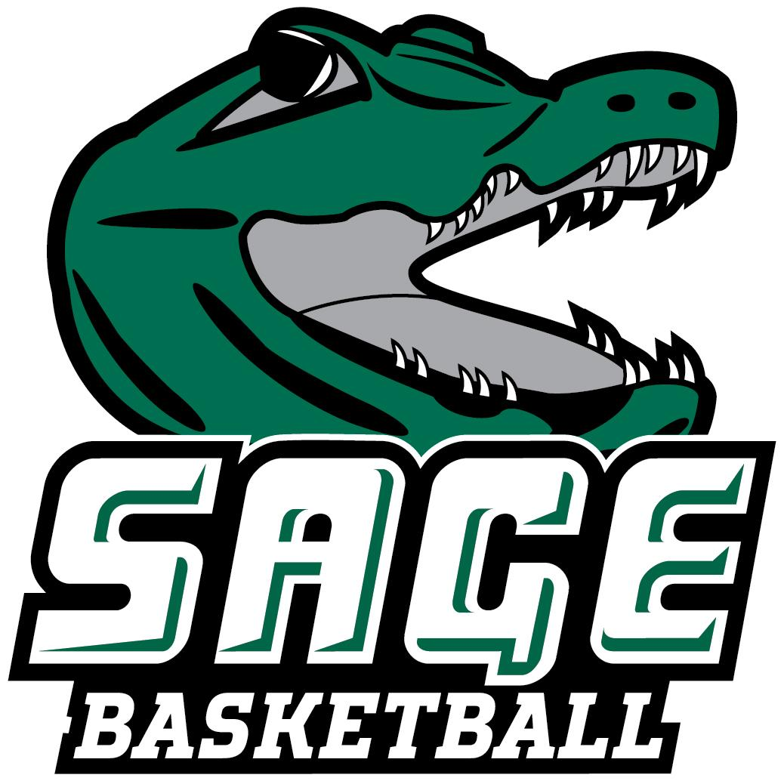
2024-25 RUSSELL SAGE COLLEGE WOMEN’ S BASKETBALL
“THE GATORS”

No. Name Pos. Cl. Ht. Hometown/High School/Previous School
1 Jaileen Soto G Fr. 5-4 Phillipsburg, NJ/Phillipsburg
2 Olivia Huneau G Sr. 5-7 Cohoes, NY/Cohoes
3 Layla Acosta G Jr. 5-7 Haines City, FL/Haines City
4 Madison Huneau G Jr. 5-6 Cohoes, NY/Cohoes
5 Riley Sitcer G/F Fr. 5-10 Coxsackie, NY/Coxsackie Athens
10 Emma Healy G Fr. 5-7 Churchville, NY/ Churchville Chili
11 Samantha Henderson F Fr. 5-6 Hillsdale, NY/Taconic Hills
12 Aniyah Kelley F Jr. 6-0 New Castle, DE/William Penn
14 Kallie Hopkins F So. 5-8 Millsboro, DE/Poly Tech
15 Angelina Schaefer G Sr. 5-5 Latham, NY/Shaker
21 Danielle Waldron G/F So. 5-7 Cayuga, NY/Union Springs
22 Isabella Seeberger G So. 5-5 Castleton, NY/Maple Hill
23 Emily Zeh F Jr. 5-11 Oneonta, NY/Oneonta
24 Malena Gereau G Sr. 5-7 Schroon Lake, NY/Schroon Lake Central
25 Lauren Sanderson G Sr. 5-6 Ravena, NY/RCS
34 Ryleigh Hughes F Fr. 5-8 Rutland, VT/Rutland

Head Coach: Michael Branche (First Season, Alfred ’14)
Assistant Coach: Eric Fluty
Volunteer Assistant: Ryan Mahon
Captains: #2 Olivia Huneau, #24 Malena Gereau, #25 Lauren Sanderson

Pronunciation Guide
2 Olivia Huneau Hue-No
4 Madison Huneau Hue-No
14 Kallie Hopkins Cali
22 Isabella Seeberger Sea-burger
23 Emily Zeh Zee
24 Malena Gereau Ja-Row
HC Michael Branche Branch

January 8, 2025

Office of Athletic Communications 140 New Scotland Avenue • Albany, NY 12208
www.sagegators.com

